## horizontal line

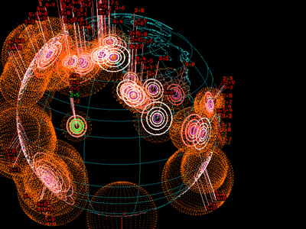

Earthquake-damage-visualization

25.10.2019

* **Basic Info.** The project title, your names, e-mail addresses, UIDs, a link to the project repository.
  + Project title: Earthquake Damage Visualization in SFO.
  + Repo: <https://github.com/nataliamelissas/earthquake-damage-visualization>
  + Viraj Rathod, [viraj.rathod@utah.edu](mailto:viraj.rathod@utah.edu), u1269659
  + Natalia Soto, [nataliamelissas@gmail.com](mailto:nataliamelissas@gmail.com), u1058711
  + Reza Sheibani, [m.sheibani@utah.edu](mailto:m.sheibani@utah.edu), u1138100
* **Background and Motivation.** Discuss your motivations and reasons for choosing this project, especially any background or research interests that may have influenced your decision.
  + This project is directly related to the research interests of one of the members. Earthquake damage prediction is one of the most popular topics in the civil engineering community. Visualizing the consequences of an earthquake with an attractive design and providing information regarding the level of vulnerability of different structures is the main goal of this project. A dataset, describing the seismic behavior of buildings in San Francisco city during a hypothetical M7.0 earthquake is available and will be implemented in the project (Fig. 1).

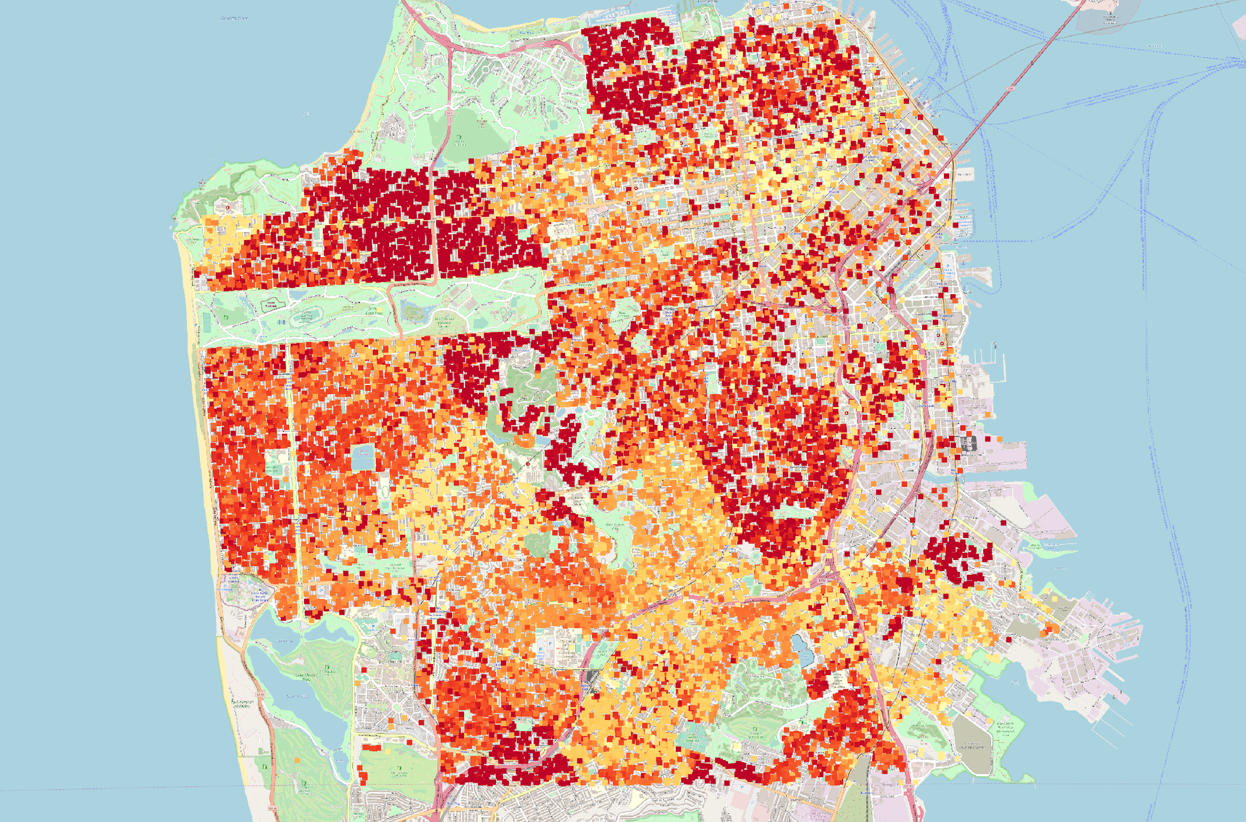

Fig. 1. The extent of damage to buildings in San Francisco after the hypothetical earthquake

* **Project Objectives.** Provide the primary questions you are trying to answer with your visualization. What would you like to learn and accomplish? List the benefits.   
    
  Primary Questions:
  + How do people best visualize geographical spaces in conjunction with data?
  + What areas of San Francisco have stronger buildings than others?
  + What is the median repair cost of re-constructing buildings in the area?
  + What primary material are buildings built within different areas of San Francisco?
  + How does the building age and building material cost affect the amount of damage incurred?

Learn and Accomplish:

* + Use Google’s API to add Google Maps to project, or another open-source map
  + How to create a live website
  + Learn what popular data vis designs currently exist for the type of data we’re trying to display
* **Data.** From where and how are you collecting your data? If appropriate, provide a link to your data sources.
  + The earthquake ground motion data is generated for the Hayward fault in the Bay Area and is obtained from [1]. The building’s responses to the seismic loading are simulated by dynamic finite element analyses. The simulation is studied in a collaboration between the SimCenter at NHERI [2] and one of the team member’s research group.
* **Data Processing.** Do you expect to do substantial data cleanup? What quantities do you plan to derive from your data? How will data processing be implemented?
  + The data is present in the format of a CSV file, so no need for data cleanup necessary for parsing it to the visualization.
  + Among the quantities that we will derive are:
    - Buildings year built
    - Buildings structural type
    - Earthquake intensity at each building’s site
    - Repair cost of the building after the earthquake
    - Occurrence of collapse
* **Visualization Design.** How will you display your data? Provide some general ideas that you have for the visualization design. Develop **three alternative prototype designs for your visualization**. Create **one final design that incorporates the best of your three designs**. Describe your designs and justify your choices of visual encodings. We recommend you use the [Five Design Sheet Methodology](http://fds.design/).

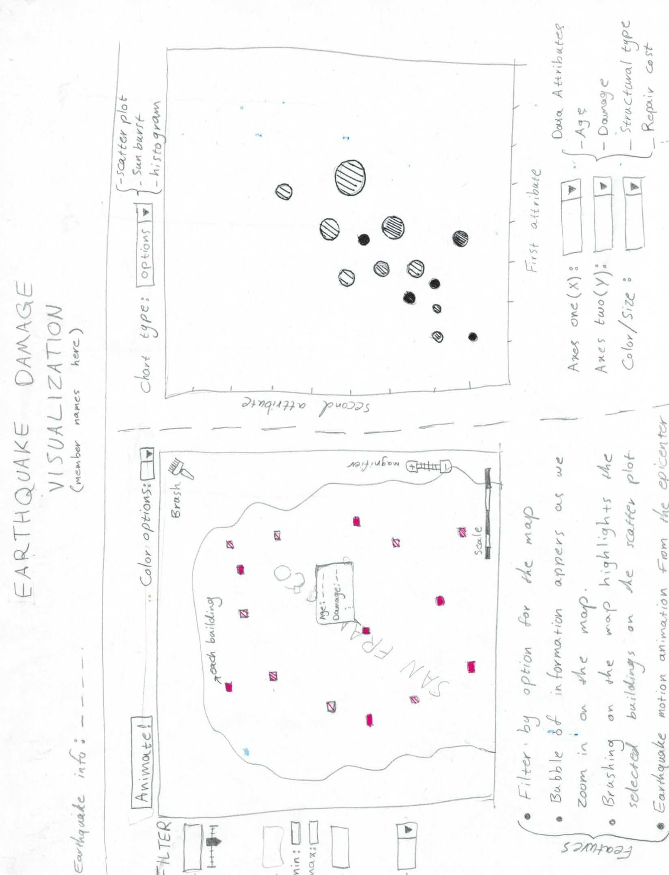

Fig. 2. The main page design sketch

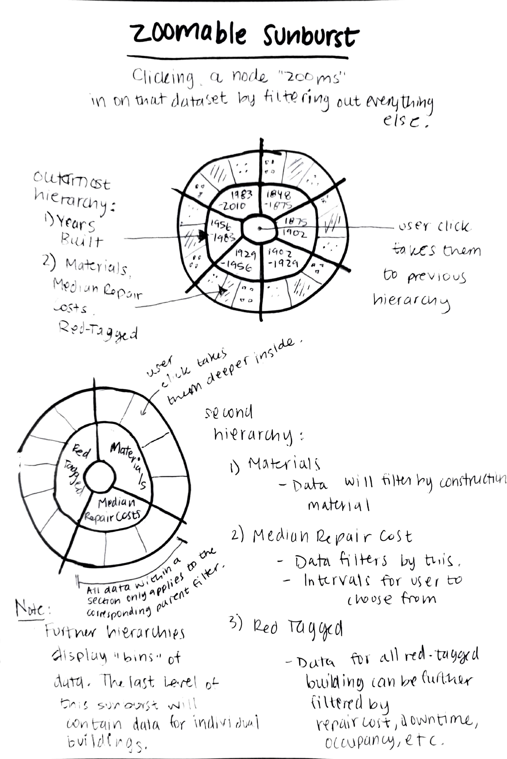

* **Must-Have Features.**
  + Showing earthquake damage on a map for each building.
  + Scatterplot: Linking the map with a scatter-plot figure to show different features of the data.
  + Semantic zooming: The reason we need to have semantic zooming is to have a dedicated view window.
  + Brushing: To see the data for a specific set of buildings.
  + Histograms: To visualize each column through a dropdown menu.
* **Optional Features.**
  + Transitions in the scatterplots.
* **Project Schedule.** Make sure that you plan your work so that you can avoid a big rush right before the final project deadline, and delegate different modules and responsibilities among your team members. Write this in terms of weekly deadlines.

|  |  |  |
| --- | --- | --- |
| **Action Item** | **Expected Date** | **Actual Date** |
| Project Proposal | 10/25/2019 | 10/25/2019 |
| Visualization Design discussion | 10/28/2019 | *TBD* |
| Zoomable Sunburst data is modified to be filterable | 11/04/2019 | *TBD* |
| Completion of Visualizations phase I | 11/05/2019 | *TBD* |
| Linking map plot with other types of visualization plots | 11/08/2019 | *TBD* |
| Completion of Semantic zooming and Must-Have features | 11/12/2019 | *TBD* |
| Adding additional features | 11/19/2019 | *TBD* |
| Final Project Completion | 11/27/2019 | *TBD* |

**References**

[1] Rodgers, A. J., Pitarka, A., Petersson, N. A., Sjögreen, B., & McCallen, D. B. (2018). Broadband (0–4 Hz) ground motions for a magnitude 7.0 Hayward fault earthquake with three‐dimensional structure and topography. *Geophysical Research Letters*, *45*(2), 739-747.

[2] Wael Elhaddad, Frank McKenna, Mats Rynge, John B. Lowe, Charles Wang, & Adam Zsarnoczay. (2019, February 1). NHERI-SimCenter/WorkflowRegionalEarthquake: rWHALE (Version v1.1.0). Zenodo.